useOptimistic() is a React Hook that lets you update the UI immediately while waiting for an asynchronous operation, such as an API request, to finish.

It is useful when you want your application to feel fast and responsive, even when the server takes some time to respond.

For example:
- You click a Like button, and the count increases immediately.
- You send a chat message, and it appears immediately in the conversation.
- You add a comment, and it appears before the server confirms it.
- You update a task's status, and the UI changes while the request is processing.

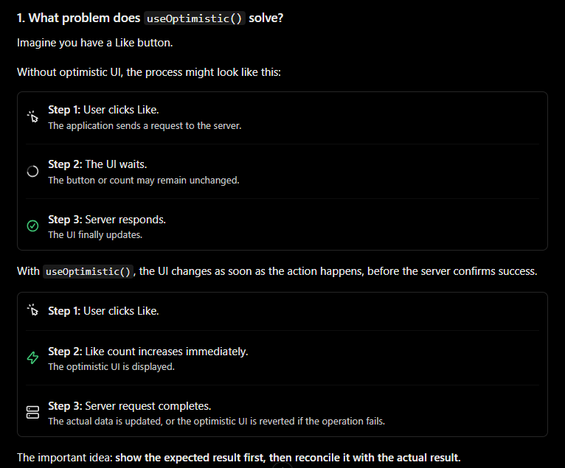

Syntax of useOptimistic()
const [optimisticState, addOptimistic] = useOptimistic(
state,
updateFunction
);

There are two return values:
Value | Meaning
optimisticState | The state you display in your UI, including temporary optimistic updates.
addOptimistic | A function you call to apply an optimistic update.

Arguments:
Argument | Meaning
state | The actual or current state, usually coming from props or another source of truth.
updateFunction | A function that calculates the optimistic state from the current state and an action.

The second argument is optional if you simply want to provide an optimistic replacement state, rather than calculate a new state from an action.

For example:
const [optimisticCount, setOptimisticCount] =
useOptimistic(count);

Here, setOptimisticCount(10) temporarily displays 10 while the optimistic action is active.

Real-time example: Like button
Let's build a Like button where the count updates immediately when the user clicks it.

Example using React 19 and useTransition().

import { useState, useOptimistic, useTransition } from "react";

function LikeButton() {
const [likes, setLikes] = useState(10);
const [optimisticLikes, addOptimisticLike] =
useOptimistic(likes);

const [isPending, startTransition] = useTransition();

const handleLike = () => {
startTransition(async () => {
// 1. Immediately increase the displayed count
addOptimisticLike(optimisticLikes + 1);

// 2. Simulate an API request
await new Promise((resolve) => setTimeout(resolve, 2000));

// 3. Update the actual state after success
setLikes((currentLikes) => currentLikes + 1);
});
};

return (
<div>
<h2>Likes: {optimisticLikes}</h2>

<button onClick={handleLike}>
👍 Like
</button>

{isPending && <p>Saving like...</p>}
</div>
);
}

export default LikeButton;

How this code works

Step 1: Actual state
const [likes, setLikes] = useState(10);
This is the actual state maintained by the component. Initially, the count is 10.

Step 2: Create optimistic state
const [optimisticLikes, addOptimisticLike] =
useOptimistic(likes);
likes is the actual state.
optimisticLikes is the value you render.
addOptimisticLike temporarily changes the displayed value.

Step 3: Start the action
startTransition(async () => {
// ...
});
This marks the update as a Transition. It also gives React an action boundary in which the optimistic update can remain active while the asynchronous work is pending.

Step 4: Update the UI immediately
addOptimisticLike(optimisticLikes + 1);
The displayed count increases without waiting for the simulated API request.

Step 5: Wait for the server
await new Promise((resolve) => setTimeout(resolve, 2000));
This simulates a two-second API call. In a real application, you would use fetch, Axios, or another API client.

Step 6: Update the actual state
setLikes((currentLikes) => currentLikes + 1);
Once the request succeeds, the actual state becomes 11. React then reconciles the optimistic state with the actual state, so the displayed count remains 11.

Real-world example: Add a comment
This is one of the most useful scenarios for useOptimistic() in a React application.
Suppose you are building a social media app. When a user submits a comment, you want the comment to appear immediately rather than waiting for the API.

useState() vs useOptimistic()

Feature | useState() | useOptimistic()
Main purpose | Manage actual component state | Show temporary expected state
Updates UI | Yes | Yes
Designed for pending async actions | No, not by itself | Yes
Automatically reverts to base state when the optimistic action ends | No | Yes, when the optimistic state is no longer active
Requires updating actual state after success | Depends on your logic | Yes, if the change should persist

Remember: useOptimistic() does not automatically send API requests, save data to the database, or guarantee success. You still need to implement the actual operation.

Important rules to remember
- Use it inside an Action or Transition. For example, call the optimistic setter inside startTransition(), or use it inside a React form action.
- Update the actual state after success. Otherwise, the optimistic change will disappear when the action ends.
- Handle errors. If a request fails and the actual state remains unchanged, React removes the temporary optimistic result when the action finishes.
- Do not treat optimistic state as confirmed server data. It represents what you expect to happen, not necessarily what has happened.
- Avoid duplicate updates. If you allow multiple clicks or concurrent requests, design your state updates and API operations so that the same action is not accidentally counted twice.

When should you use useOptimistic()?
Scenario | Recommended?
Like and unlike buttons | Yes
Chat message submission | Yes
Adding comments | Yes
Adding items to a cart | Yes
Updating task status | Yes
Loading a large report where the result is unknown | Usually not
Form validation before submission | Not its main purpose

useOptimistic() is a React Hook that lets us render a temporary optimistic version of state while an Action is in progress. It improves perceived responsiveness by showing the expected result before the asynchronous operation completes. When the Action finishes, React reconciles the optimistic state with the actual state

useOptimistic() was introduced in React 19. If your project is still using React 16.8, you cannot use this Hook directly; you would need to upgrade React or implement optimistic updates using regular state management.

In React, a ref (reference) lets you access a DOM element directly or store a value that persists between renders without causing a re-render when that value changes.

In React 19, one important change is that you can pass ref as a normal prop to a function component. You no longer need forwardRef() for this purpose.

What does useRef() return?
An object with a mutable .current property.

Does updating a ref trigger a render?
No.

Why use ref in React?
DOM access or storing mutable values across renders.

What changed in React 19?
Function components can receive ref as a regular prop.

Is forwardRef() required in React 19?
No, not for passing refs to function components.

What does useImperativeHandle() do?
Exposes selected methods or values through a ref.

What is a callback ref?
A function React calls when attaching or detaching a ref.

React Server Components (RSC)
React Server Components are React components that run on the server instead of running in the browser. They let you render UI on the server, access databases or backend resources directly, and send the rendered result to the client without shipping that component's JavaScript to the browser.
They are especially useful in modern React applications built with frameworks such as Next.js

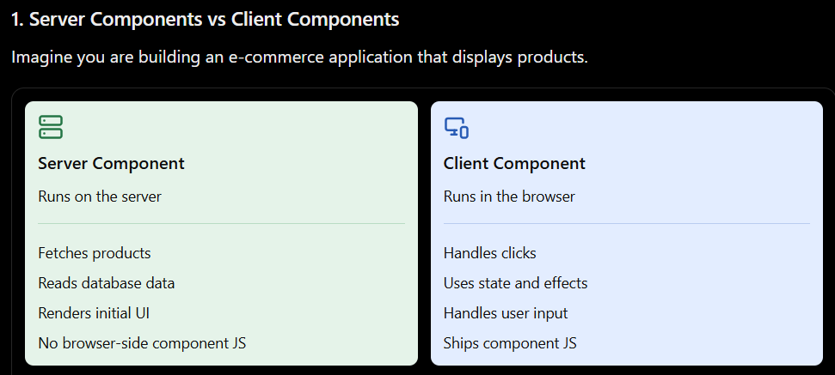

Easy real-world example
On a product page:
- Product name and price → Server Component.
- Product list fetched from a database → Server Component.
- Add to Cart button → Client Component.
- Quantity counter → Client Component.
- Search input with interactive filtering → Client Component.
The key idea is to use the server for data and rendering, and the browser for interaction.

What can and cannot be used?
Feature | Server Component | Client Component
Fetch data with async/await | Yes | Yes, with appropriate client-side patterns
useState() | No | Yes
useEffect() | No | Yes
onClick event handlers | No | Yes
Access server-side database directly | Yes, when configured | No, not safely from browser code
Access window or localStorage | No | Yes
Keep component JS out of browser bundle | Yes | No
Render HTML/UI | Yes | Yes

Important: A Server Component must not expose database credentials, API secrets, or private server data in its rendered output or props

Server Components vs SSR
These terms are related but different.
Server-Side Rendering (SSR): A rendering technique that produces HTML on the server for a page request.
React Server Components (RSC): An architecture that lets components execute on the server and participate in a server-to-client component model.
A framework can use both together. For example, Next.js can server-render the initial page HTML and use Server Components to render server-owned portions of the component tree.

React Server Components are components that execute on the server and allow us to fetch data and render UI without sending their component JavaScript to the browser. They can improve initial loading performance and reduce client-side JavaScript. They cannot use client-only hooks such as useState and useEffect, or browser event handlers. When interactivity is needed, we use Client Components with the "use client" directive. In Next.js App Router, Server Components are the default.

Remember this rule: Use Server Components for server-side data and rendering; use Client Components for state, effects, browser APIs, and user interactions.

What is Metadata
Metadata is data that describes other data. It gives additional information about a piece of data, such as its name, type, size, author, or creation date.
For a frontend developer, metadata is commonly used in HTML, React, APIs, and JavaScript applications.

Metadata is data that describes other data. In web development, it provides additional information about a webpage, API response, file, or database. For example, HTML metadata includes the page title, description, character encoding, and viewport settings. It helps browsers, search engines, and applications interpret and handle data correctly.

Metadata in HTML
In HTML, metadata is usually defined inside the <head> tag. It provides information to browsers, search engines, and other services.

Element | Purpose
<title> | Defines the page title shown in the browser tab
charset | Specifies the character encoding
description | Describes the page for search engines and previews
viewport | Helps the page display correctly on mobile devices

Important: Metadata generally describes the page rather than displaying its content directly.

Types of metadata you should know
HTML metadata: Page title, description, viewport, character encoding.
SEO metadata: Information that helps search engines understand and present a page.
API metadata: Pagination, timestamps, request IDs, and result counts.
File metadata: File type, size, author, and creation date.
Database metadata: Information about tables, columns, data types, and constraints.
React/framework metadata: Page titles, descriptions, and other document-level information.

